Directory One

The Complete Internet Solution

Children say: if they could only have one media,
they would choose Internet over television or telephone.
– Knowledge Networks/Statistical Research, 2002



What We Do: The Complete Internet Solution

We build successful, profitable web presences. At Directory One, we provide all services necessary to create, maintain and promote websites that work:

- website promotion (search engine optimization & sponsored listings management)
- website design and content creation
- hosting
- domain name registration
- e-commerce solutions (secure credit card transactions and shopping carts)
- database solutions (real-time inventory, customer tracking)

Directory One recognizes that the ideal Internet solution is different for each of our clients. Whether you are interested in a new web presence or need to improve or promote an existing website, we will work with you to determine the solution that will provide the greatest return on investment for your company.

Why Directory One?

Obviously, Directory One is not the only company offering Internet solutions. We do, however, offer several things that many of our competitors cannot:

- The best customer service available. You'll never be waylaid by middle-men afraid of "wasting" their superiors time. All Directory One employees are available to our customers including the owner and the chief operations officer.

- A wide variety of plans and packages including custom-built solutions tailored to your company’s needs.

- An Internet-training program, available at no cost to all current customers. We will teach you how to update your own site, add and remove pictures, change promotional information and much more.

- A customer loyalty plan that provides deeper discounts the longer you stay with us. We are interested in establishing long-term relationships with our clients.

- One-stop-shopping for your website. We provide all services necessary to create a complete web presence. You won’t have to worry about coordinating multiple providers and multiple bills.

Website Marketing and Promotion

Driving Targeted Traffic to Your Website…

What is It?
Directory One markets websites through search engine optimization (also called website promotion). Search engine optimization is the process of making your site more search-engine-friendly. Optimized, search-engine-friendly sites are more likely to be found and well-ranked by search engines such as Google, Yahoo and MSN.

An optimized site, such as Directory One’s will show up in the first ten to thirty results under appropriate keywords as shown below.

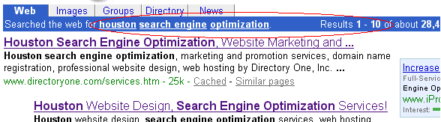

Benefits

- You will be easily found on the Internet by current and prospective clients.
- You will create a strong and stable web presence. Easily found sites are more likely to generate repeat visitors and high product/company brand-recognition.
- Your website will receive more targeted traffic. Because your website will be found by typing keywords into a search engine, your visitors will not be random surfers but will be motivated, prospective buyers interested in the products or services you provide.

Why Directory One?

- Directory One is an established company experienced in professional search engine optimization strategies. We have an extensive list of references available per request.
- We do not employ shady, spammy, illegitimate or “quick-fix” optimization. Such strategies can get your site banned from search engines. We adhere strictly to Google’s optimization guidelines* and are concerned with the long-term success and stability of your website’s rankings.
- Directory One provides you with a personal optimization expert who will be working on your site and who will be available when you have any questions or problems concerning your optimization. Because you will always be communicating directly with the optimizer working on your site, you will never have to worry about your wishes being miscommunicated by a third party.
- Directory One can integrate your search engine optimization plan with a unique sponsored listings purchase and management plan. We will manage your listings and pay for your clicks. (Sponsored listings appear under “sponsored listings” headings in major search engines. These programs are generally run on a pay-per-click basis: every time someone clicks on the sponsored listing, the owner of the listing pays a certain set amount.) With Directory One, you can opt to pay a flat fee every month regardless of clicks. Please see our website for more details: www.directoryone.com.
- Directory One will continuously monitor your website’s ranking and will maintain your optimization ensuring that you keep the rankings that you paid for. As search engines improve their search algorithms to ensure more accurate results, your optimizer will keep track of these changes and make sure that your optimization is up-to-date with the latest search methods.
- Directory One sets no limits on the amount of time we will spend optimizing your site. We keep going until we get it right.
- Directory One search engine optimization customers enjoy free website updates and maintenance.

*Please see: www.google.com/webmasters/seo.html

Search Engine Optimization Facts and Figures

Research shows that more than 80 percent of the worlds estimated 430 million Internet users use search engines and directories to look for products, services and information. (internetstats.com, June 2001)

Of these 340 million prospective clients, roughly 82% do not look past the first 3 pages of search results (iProspect, 2002).
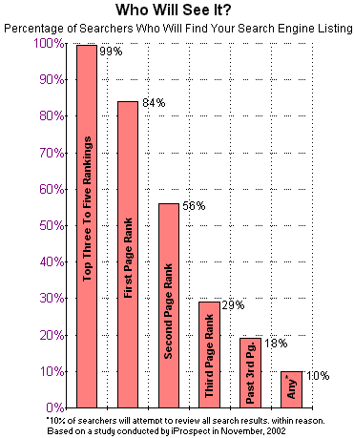 | Search engine positioning is important. Ideally your site should rank in the top page--but at least in the top three--to get significant traffic from your inclusion in search engines. If you have a site that is showing up past the third page of search engine results, your chance of being found is 18% or less. (See chart left.)  In a recent NPD Group study, it was shown that online purchases are more likely to originate from search engines than from all other sources combined.  This study also showed that:  1. Consumers are 5 times more likely to purchase your products after seeing search listings than banner ads.  2. More than twice as many people gave a more favorable opinion of companies in the top three search positions than those featured in banner and list ads.  3. In unaided recall, search listings outperformed banners and buttons by three to one. Other studies have also supported the position that search engine positioning is the number one Internet-method for brand recognition.

Search engine submission by itself will not aid your search engine ranking. Only search engine optimization, whether in- or out-sourced, can help your ranking.

Directory One has repeatedly achieved steadily growing ranks for its optimization customers. Depending on the optimization plan purchased and the type of site being optimized, within the first nine months of optimization Directory One clientele can expect between two- and one-hundred thousand hits (per month) over their original hit count. Within the first twenty-nine months of optimization Directory One clientele can expect between thirty- to three-hundred thousand hits (per month) over their original hit count. (see charts below).

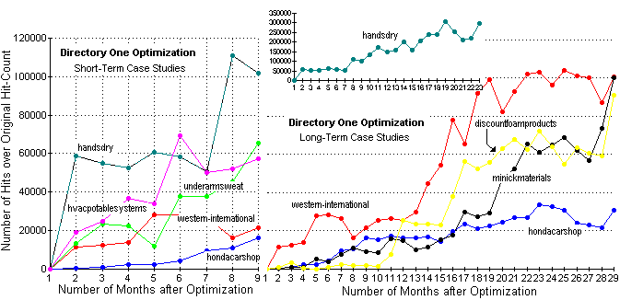
Search Engine Optimization Plans and Packages

The following packages are our most popular search-engine optimization packages. Besides the following packages, Directory One Inc. is also very proud of its custom-made optimization packages. If none of the traditional packages suits your company’s needs, please don’t hesitate to tell Directory One what your optimization goals are. We will create and price a plan specifically designed for your company.

 | The Saver | Bronze | Gold | Gold+ | The Ultimate
Description | Designed for small businesses with limited budgets. | An affordable package with regular web-site maintenance and more pages of optimization than the Saver. | Provides more pages of optimization and more web-site maintenance and extras than the Bronze. | Almost identical to the Gold, but includes the purchase and management of sponsored listings. | Simply the best optimization that money can buy.
Monthly Price | $99/month | $149/month | $249/month | $299/month (optimization)  +  $100/month (sponsored listings purchase and management)  -------------------  $399/month | $699/month (optimization)  +  $300/month (sponsored listings purchase and management)  -----------------------  $999/month
Yearly Price (10% Discount Included) | $1069/year  (save $119) | $1609/year  (save $179) | $2689/year  (save $299) | $4309/year  (save $479) | $10,789/year  (save $1,199)
Hand Submission to all Major Engines | Yes | Yes | Yes | Yes | Yes  Includes extra submissions such as submissions to harder-to-get-into engines, new engines, and any additional engines of your choice.
Projected Rankings | 2 to 5 results within the top 30 | 5 to 10 results within the top 25 | 10 or more results within the top 20 | 10 or more results within the top 20 | 20 or more results within the top 15
Pages Optimized* | 2 | 5 | 10-15 | 10-15 | unlimited
Sponsored Listings | No | No | no | Yahoo, Lycos, Overture, AltaVista, Search and several others.  Sponsored listings are powered by Pay-Per-Clicks. WE pay for the clicks. | Includes all sponsored listings as listed in the Gold+ package, but adds: Google, MSN, Looksmart and several others.  Sponsored listings are powered by Pay-Per-Clicks. WE pay for the clicks.  Includes express inclusion in directories where available.
Monthly Reports | No | Basic Monthly Reports | Basic Monthly Reports | Traffic analyzer reports.  Ranking, traffic and keyword reports on sponsored links. | Traffic analyzer reports.  Volume and keyword capture for MSN, About, HotBot, and others.  Keyword-ranking report for major search engines including Yahoo, Google, MSN and AOL.
Regular Web Site Maintenance** | No | 1 update per month | 2 updates per month | 3 updates per month | unlimited
CheckHouston listings | 1 top 30 | 1 top 25 | 3 top 15 | 3 top 10 | 5 top 5
Web Site Design | No | No | No | No | All redesign necessary, including creation of extra pages, a site map and complete text rewrites.
*Additional pages run $30 per page start-up fee and $15/month maintenance. Optimally every page on your site should be optimized. This will allow multiple pages on your site to come up in search engine results and will, ultimately, bring you significantly more traffic. Your additional pages will be treated as though they were a part of your original plan.
**As part of our design to provide a complete internet solution to all of our customers, we provide general web site maintenance (i.e. updating newsletters, uploading photos, changing prices) with most search engine optimization packages at NO extra charge. We will also teach you to do these updates for yourself.

Directory One Web Site Design and Content Creation

What is it?

Web site design refers to all elements of layout, navigation, graphics and animation involved in the creation of a web site. Web site content refers to the site’s text.

Benefits and Facts
- Customers will be more likely to stay on and return to a site that has a clean, professional design. A May 2002 study by Enterpulse reported that many businesses are losing customers because of inadequate websites. Sixty-six percent of respondents never returned to websites where they have had a negative experience; and according to a recent Creative Goods report, consumers are less likely to leave sites that are well-designed and easy to navigate.
- A site must have both professional design and content to be perceived as credible. A study done in November, 2002 by Consumer Web Watch indicated that many consumer’s base a site’s credibility on the site’s visual appeal. (Almost 55% of consumer comments referred to issues of a site's overall design or look when assessing a site’s credibility.) However, more educated users will thoroughly analyze content before assessing credibility. (Only between 7 and 14% of users educated in the site’s subject matter mentioned design when assessing credibility)
- Professionally created navigation will make the site simple to use and will be less likely to frustrate visitors than unorthodox or unprofessionally designed navigation. In 2002, Newsbytes reported that factors likely to create a negative experience for users included ease-of-use, not being up-to-date and simple navigation. Around 99 percent of respondents said that a site that ‘works well’ is very important.
- Details count. A study of 1,649 online users, primarily from the United States and Finland, conducted by Stanford University's Persuasive Technology Lab and sponsored by Makovsky & Company, revealed that little things, such as misspellings, could be detrimental to a site's credibility. Out-sourcing your content creation can help eliminate such errors on your website.

Why Directory One?
Very simply, we create excellent websites:

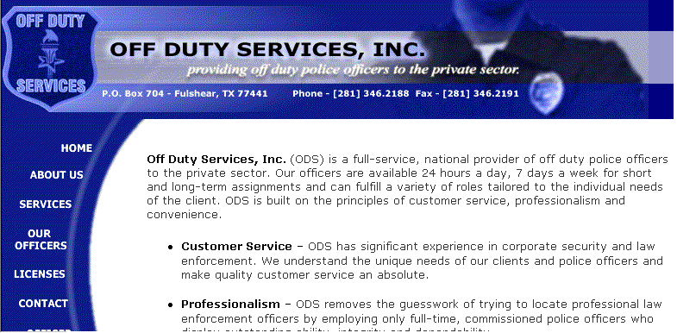
Example 1: www.offdutyservices.com Example 2: www.organizedprofessional.com

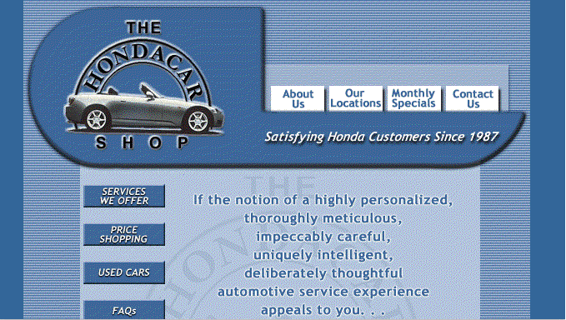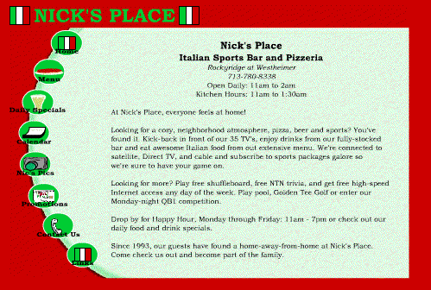
Example 3: www.hondacarshop.com Example 4: www.nicksplacehouston.com

Directory One Web Design Packages
 | Amenities | Price
The Starter | 5 Web Pages  2 scanned graphics per page  Registration with major search engines  Guest Book and Hit Counter included  One year bronze package hosting  One year domain name registration | $99.00 / Mo. (for 12 months)  or make one payment of $1,070.00 and receive a 10% discount
The Intermediate | 10 Web Pages  3 scanned graphics per page  Registration with major search engines  Guest Book and Hit Counter included  Custom design navigation bar  Logo design  One year bronze package hosting  One year domain name registration  Extras--Choose two of the following:  - Message board/forum  - Customized Feedback/response form  - Customized email form (email stationary)  - Site-specific search engine  - One-Year of free, personalized monthly website statistics reports (traffic analyzer)  - Creation of homepage content (text) | $124.99/ Mo (for 12 months)  or make one payment of $1,349 and receive a 10% discount
The Graduate | 20 Web Pages  4 scanned graphics per page  Registration with major search engines  Guest Book and Hit Counter included  Custom navigation bar  Logo design  Five hours of custom scripting such as Java or Flash  Creation of content (writing of text from scratch) of three pages  One year silver package hosting  One year domain name registration  Extras--Choose three of the following:  - Message board/forum  - Customized Feedback/response form  - Customized email form (email stationary)  - Site-specific search engine  - One-Year of free, personalized monthly website statistics reports (traffic analyzer)  - Creation of homepage content (text) | $269.99/Mo  (for 12 months)  or make one payment of $2,915 and receive a 10% discount
The Works | 50 Web Pages  Unlimited scanned graphics  Registration with major search engines  Guest Book and Hit Counter included  Custom navigation bar  Logo design  Site Map  Ten hours of custom scripting such as Java or Flash  Up to 5 custom graphics  Creation of content (writing of text from scratch) of nine pages  One-time Search Engine Optimization Included!  First year of updates is completely free.  Two years platinum package hosting  Two years domain name registration  Extras--Includes all of the following:  - Message board/forum  - Customized Feedback/response form  - Customized email form (email stationary)  - Site-specific search engine  - One-Year of free, personalized monthly website statistics reports (traffic analyzer)  - Creation of homepage content (text)  The works package provides a no-holds-barred approach to web design. You dream it, we build it. | $349.99/ Mo (for 24 months)  or make one payment of $7,559 and receive a 10% discount

Directory One Hosting

What is it?
“Hosting (also known as Web site hosting, Web hosting, and Webhosting) is the business of housing, serving, and maintaining files for one or more websites. More important than the computer space that is provided for website files is the fast connection to the Internet. Most hosting services offer connections on T1 lines. Typically, an individual business hosting its own site would require a similar connection and it would be expensive. Using a hosting service lets many companies share the cost of a fast Internet connection for serving files.” -- searchWebServices.com

Why Directory One?
The following are ten of the eighteen questions to ask your host (according to Internet Magazine, 2003) and our answers. To see the full list, please visit our website: www.directoryone.com.

How much is this going to cost me? We have three advertised hosting packages. However, Directory One also offers dedicated servers and custom hosting packages if the more popular hosting packages do not suit your needs.
Bronze Hosting | Silver Hosting | Platinum Hosting
200 MB Storage Space  3000 MB/ Mo. Data Transfer  5 POP3 E-mail Accounts  Password Protection  Full Site Back-ups Bi-monthly  $22.00 Mo. | 400 MB Storage Space  4000 MB/ Mo. Data Transfer  10 POP3 E-mail Accounts  Password Protection  Full Site Back-ups Monthly  Limited Database and E-commerce Capabilities  Support for PHP  $49.00 Mo. | 800 MB Storage Space  8000 MB/ Mo. Data Transfer  Unlimited E-mail Accounts  Secure Server and Password Protection  Full Site Back-ups Weekly  Extensive Database and E-commerce Capabilities  Support for PHP and MySQL  $99.00 Mo.
All of our plans include: Frontpage Support. FTP Access. Personal CGI Bin. All email accounts include optional forwarding and autoresponse. Unlimited Free Technical Support. ICQ (instant messaging) technical support. Super-Fast 0C48 Connection. Traffic Analysis Reports. Standard Guestbook and Feedback Form. Hit Counter.

What's your name? Are there many of you in the support center? Can I ask for you personally? You may always ask for your contact personally. Our support center is fairly small. However, we see this as an advantage. Our support personnel are a close-knit group that communicate freely with one another. You will never talk to one customer support representative who promises you one thing, only to talk to a second representative the next day who contradicts the first. Moreover, we pride ourselves on being available to our clients, even at the executive level.

What kind of security features can I choose from? Our servers offer password protection for bronze and silver hosting customers. Our secure servers boast SLL--secure socket layers—and are reserved for platinum hosting customers. Sites interested in developing e-commerce, creating extensive databases, and allowing credit card transactions will need platinum hosting.

What access speeds can I expect? We connect to extremely fast 5 OC48 backbones. OC48 connections transfer data at 2.5 gigabits/second (1600 times the speed of a T1).

Will my content be backed up regularly? Back-ups for all hosting customers are done regularly, although the time between back-ups varies with the hosting package purchased. If your site is designed and updated by Directory One, your site is also backed up before and after any major design or content changes.

What specific software/technology do you support? All of our severs support Frontpage extensions and FTP access. Our secure servers support PHP and MySQL database capabilities. You will also have a personal CGI-bin supporting your website scripts. Our hosting can support extensive e-commerce capabilities from small, home-based sites to corporate solutions.

What assurances will I get in the way of redundancy? Although our host is very reliable, all host-servers go down occasionally. The down time for our sites has always been insignificant (less than 1% of the calendar year). However, if you are concerned with down time, redundancy may be purchased: multiple connections, site mirroring, and multiple mail routing are available.

Can I order regular traffic analysis reports? Traffic Analysis Reports are included in all our hosting packages.

Do you offer around the clock support, and how much will it cost me? We offer 24/7 network monitoring. Unfortunately, Directory One is not yet able to offer 24/7 phone support. We do, however, provide an 800 number to all our customers and are readily available from 9am to 5pm Monday through Saturday. Our ICQ (Instant Messaging) Technical Support ID is #84434371. All technical support services at Directory One are free of charge.

Anything else I should know? Directory One prides itself on incredible customer service. Please, call us frequently. Ask any questions that come to mind. Whether you pay $22 a month or $2200, we value your business.

Directory One E-commerce Solutions

What is it?
E-commerce (short for electronic commerce) refers to any business conducted on-line. The term E-commerce solution refers to any element of a website that aids in the execution of such business (such as shopping carts, on-line credit card processing, secure order forms, etc.)

E-Commerce Facts and Figures

- According to a 2003 study done by Ipsos-Reid, almost 62% of Internet users worldwide have purchased something online (up dramatically from 36% in 2000). In the United States, 72% percent of American adults have been online in the last month and 77% of these have reported buying a product or service online.
- While skeptics predicted the death of e-commerce during the 2001 “dot-com bust,” online sales continued to grow. In fact, online sales have grown every quarter since the United States Census Bureau began tracking them in fourth quarter 1999. (see chart below)

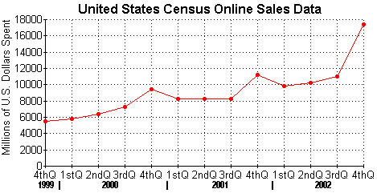
All data above taken directly from United States Census findings except for 4thQ 2002
which is taken from the annual January 2002 BizRate study until Census data is reported.

- E-commerce is convenient. More and more shoppers are finding they prefer at-home 24-7 shopping to fighting the traffic and crowds. A 2002 study by the Pew Internet and American Life Project showed that almost 30% of people who had bought something online now spend less time in stores. Online shopping had its first $2 billion dollar week the first week of December 2002 and its most lucrative day ever on Monday, Dec. 8, 2002 at $367.05 million in sales. (comScore Networks)

Why Directory One?

- Directory One is an experienced e-commerce provider interested in providing stable, long-term e-commerce solutions for its customers. We create solutions that are professional, easy to use, and dependable. We do not try to “make a quick buck” by selling extra bells and whistles superflous to your solution.
- Directory One creates custom e-commerce solutions tailored specifically to your company’s needs.
- Directory One provides a wide-range of e-commerce solutions and can create packages appropriate for a wide-range of clients from small, home-based businesses to corporate solutions. Among the solutions we provide are: real-time, credit card processing and secure order forms, dynamic shopping cart technology, package/shipment options and tracking, email order confirmations and site-specific search engines. For more specifics on these options, please visit our website: www.directoryone.com

Directory One Database Solutions

What is it?
A database is a collection of information (in this case usually customers or products) searchable by category. A web-based database is a database that is accessible through a web-based interface either by all people who access the website or by specific users (i.e. members or personnel cleared for access). For example, Amazon.com uses a web-based database to allow its customers to find books by searching under authors, book titles or subject matter. Database integration is the process making a current database web-accessible.

Benefits
- Through a web-based database your customers can search your products online, view prices, specials and current inventory.
- Web-based databases allow for real-time inventory. When a customer orders an item online, the item is automatically deducted from your inventory and your website is updated to reflect this.
- A web-based customer database can help a company keep track of customers and can allow customers to create personalized accounts. Customers create personal profiles or accounts at their favorite sites so they do not have to reenter information such as name, address, and credit card billing information.
- A web-based customer database can help a company keep track of customer-preferences. When a customer arrives at a site and logs-in to a personal account, the site can provide product recommendations based on stored preferences. Many customers will also be kind enough to receive opt-in emails (emails they have agreed to receive as opposed to unsolicited emails or SPAM). A customer database can help keep track of who has decided to receive these emails and what offers and promotions might be most interesting to them.
- Web-based databases are accessible anywhere there is Internet access. You don’t have to be at your office to update or review information.

Why Directory One?
Directory One has experience integrating numerous types of databases from various industries. Our database customers range from auto dealers and apartment locators to search engines and staffing agencies. Directory One is also prepared to create your web-based database from scratch if you do not currently have a customer or product database. Furthermore, as part of your database set-up, Directory One will train you to update your database through a web-based interface at no extra cost.

Directory One Complete Internet Solutions

Directory One provides the complete Internet solution for your company. Whether you need a simple two or three page website for a home-based business, or you need an extensive website with comprehensive optimization, e-commerce and database solutions, Directory One can create a custom solution tailored to your needs and budget.

All-inclusive solutions (including search engine optimization, website design and content creation, hosting, domain name registration, database integration, and e-commerce solutions) can start as low as $374 a month including start-up fees and $249 a month after start-up fees have been paid in full.

More Information

By Internet | By Phone | By Mail
www.directoryone.com  info@directoryone.com  ICQ: #84434371 | Local: 713-465-0051  National: 1-800-477-1324  Fax: 713-465-8589 | 9135 Katy Freeway  Suite 204  Houston, TX 77024

